**Assignment 2 Cover Sheet**

|  |  |
| --- | --- |
| **CASE STUDY NAME** | Diet Planning & Health Check-up System |
| **PROJECT ID** | MLB_15.01_07 |

**Group Details:**

|  |  |  |
| --- | --- | --- |
|  | **Student Registration Number** | **Student Name** |
| **1** | IT22575562 | WIJEKOON W.M.M.G.K.P |
| **2** | IT22567642 | THILAKARATHNA P.L.B.H |
| **3** | IT22591098 | JAYALATH J.P.R.J |
| **4** | IT22566034 | PERERA K.C.D |
| **5** | IT22217622 | HETTIARACHCHI A.N.M |

**Assignment 2 Certify Sheet**

|  |
| --- |
| I hereby certify,  The attached is my own work and no further changes will be made.  I have contributed in this assignment to the best of my ability.  And I understand,  I may be subject to student discipline processes in the event of an act of academic misconduct by me including an act of plagiarism or cheating. |

|  |  |  |  |
| --- | --- | --- | --- |
|  | **Student Registration** |  |  |
| **Student Name** | **Number** | **Date** | **Signature** |
| Hettiarachchi A N M | IT22217622 | 29.05.2023 |  |

**Student Details:**

|  |  |  |
| --- | --- | --- |
| **Number** |  | 001 |
| **Name** |  | Register |  |
| **Summery** |  | User will be able to register to the website by creating an account |
| **Priority** |  | 01 |
| **Pre-Condition(s)** |  | Users must visit the website |
| **Post-Condition(s)** |  | The system sends an email of gratitude to a user with a note to confirm successful registration |
| **Primary Actor(s)** |  | User-client |
| **Trigger** |  | client chooses to register |
| **Main Scenario** | **Step** | **Action** |
|  | 1 | User navigates to the “**sign up**” page |
|  | 2 | User clicks on the "**register**" button |
|  | 3 | System loads and displays register requirements |
|  | 4 | User enters the requirements requested and clicks next |
|  | 5 | User provides a suitable profile photo |
|  | 6 | System requests the user to enter a password |
|  | 7 | User keys in a suitable password |
|  | 8 | System requests the user to re-enter the password |
|  | 9 | User re-enters the password |
|  | 10 | User confirms by selecting “**confirm password**” |
|  | 11 | user clicks on the "continue" button |
|  | 12 | system store up the user details and opens a new account |
|  | 13 | system sends an confirmation email to the user |
|  | 14 | User opens the email and confirms |
|  | 15 | User logs into his new account |
| **Extensions** | **Step** | **Branching Action** |
|  | 8a | User enters a password that doesn’t fit the requirements |
|  | 9a | User enters the incorrect password during re-confirmation |
|  | 12a | User fails to get the email |
|  | 12b | User requests the system to send the email again by clicking on**” Resend email”** |
|  | 12c | System resends email to the user |
|  |  |  |

**Part 1**

**1. Use case scenario – Register**

Part 2

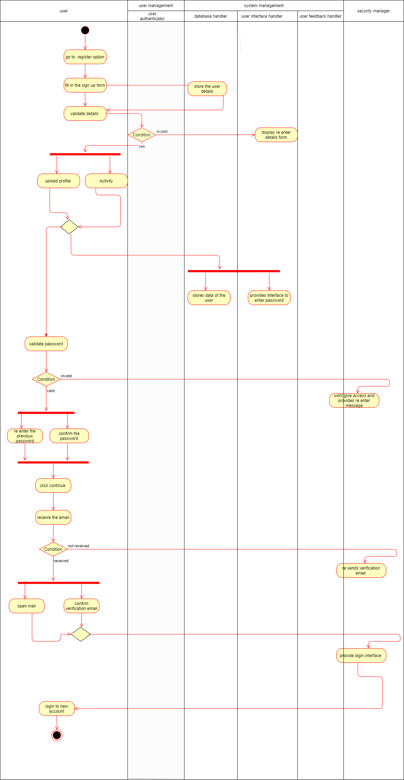

**Assignment 2 Certify Sheet**

|  |
| --- |
| I hereby certify,  The attached is my own work and no further changes will be made.  I have contributed in this assignment to the best of my ability.  And I understand,  I may be subject to student discipline processes in the event of an act of academic misconduct by me including an act of plagiarism or cheating. |

|  |  |  |  |
| --- | --- | --- | --- |
|  | **Student Registration** |  |  |
| **Student Name** | **Number** | **Date** | **Signature** |
| THILAKARATHNA B.L.B.H | IT22567642 | 29.05.2023 |  |

**Student Details:**

**Part 01-**

**Use case scenario – Health checkup system**

|  |  |  |
| --- | --- | --- |
| **Number** | 002 | |
| **Name** | Health checkup system | |
| **Summery** | User can checkup his health and get a medical report | |
| **Priority** |  | |
| **Pre-Condition(s)** | User must have an appointment to meet a doctor | |
| **Post-Condition(s)** | 02 | |
| **Primary Actor(s)** | Registered user | |
| **Trigger** | User has decided to make an appointment | |
| **Main Scenario** | **Step** | **Action** |
|  | 01 | User logs in. |
|  | 02 | User management verifies the login details. |
|  | 03 | System displays the homepage. |
|  | 04 | User enter the health checkup system via click on the relevant button. |
|  | 05 | User enter the checkup category selecting section. |
|  | 06 | User selects the category, suitable package and preferred doctor. |
|  | 07 | User clicks the “submit details” button after his selections. |
|  | 08 | System allocates a time to user for a checkup. |
|  | 09 | System informs to user allocated time via both SMS and Email. |
|  | 10 | If user wants to change the allocated time, he calls the reception. Then the system allocates a new time for him. |
|  | 11 | If user got preferred time, then he enters payment portal. |
|  | 12 | If the payment had unsuccessfully, he enters payment portal again. |
|  | 13 | If the user makes the payment successfully, then he enters service method portal. |
|  | 14 | After user choose service method successfully health data management generate a final medical report. |
|  | 15 | If user do mistake when he choosing a service method he clicks the “cancel” button. Then system takes user into service method portal again. |
|  | 16 | User management update the database. |
| **Extensions** | **Step** | **Branching Action** |

|  |  |  |
| --- | --- | --- |
|  | 2a | If the username or password is incorrect System prompt the error message “Username or password is incorrect” and then display the login page. |
|  | 11a | User choose a prefer payment method, enter relevant details and submit details. Payment management check the entered details and if details are correct display “payment successful”. If the details are incorrect display a error message and refer user to payment portal again. |
|  | 13a | User choose a preferred method.If user selected method successfully and clicks “confirm” button.System displays successful message.If it is unsuccessful then user clicks “cancel” and choose a method again. |

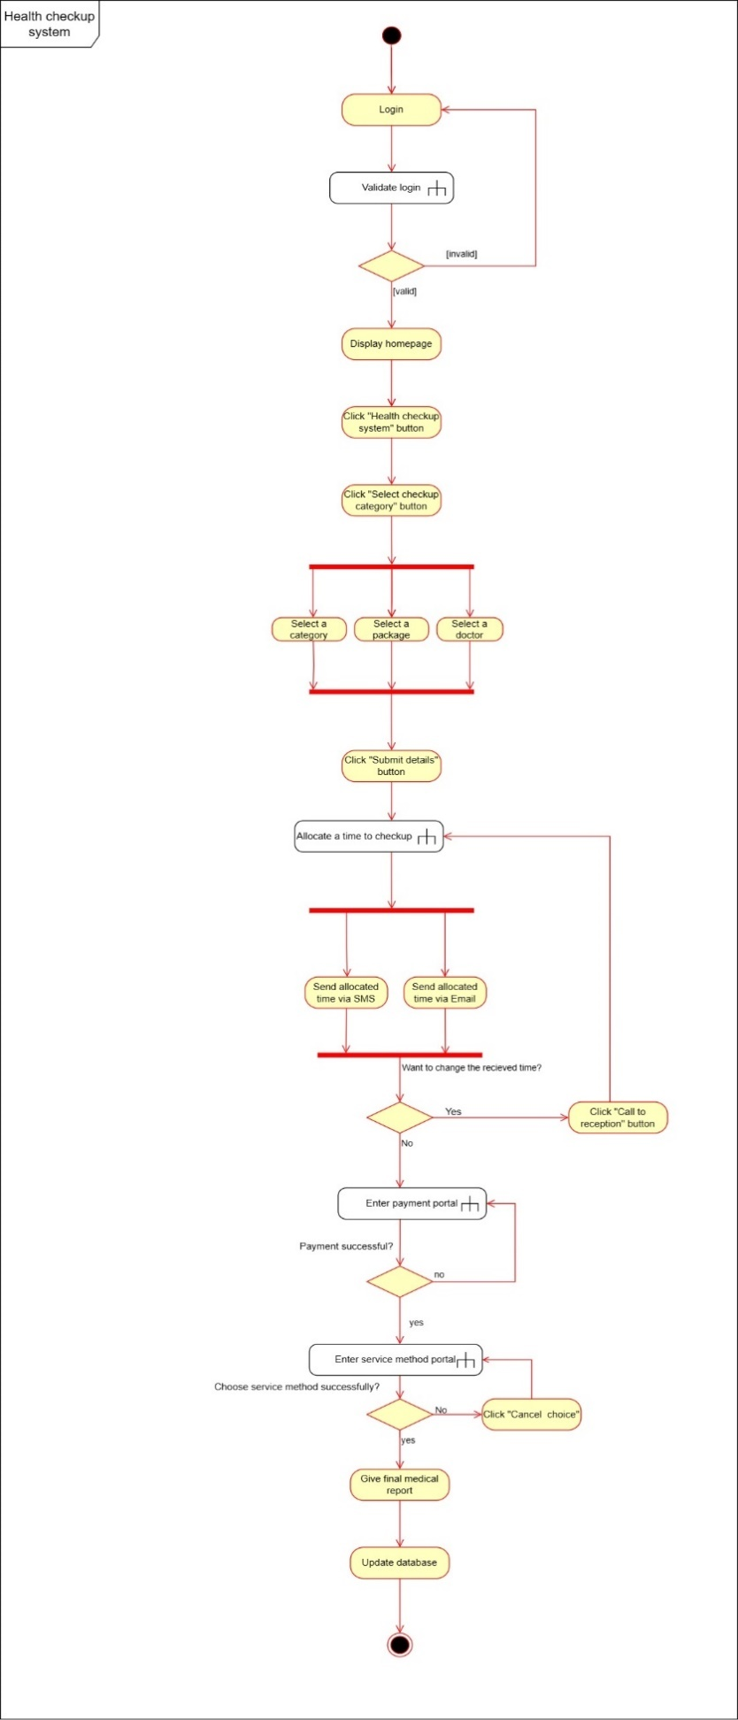

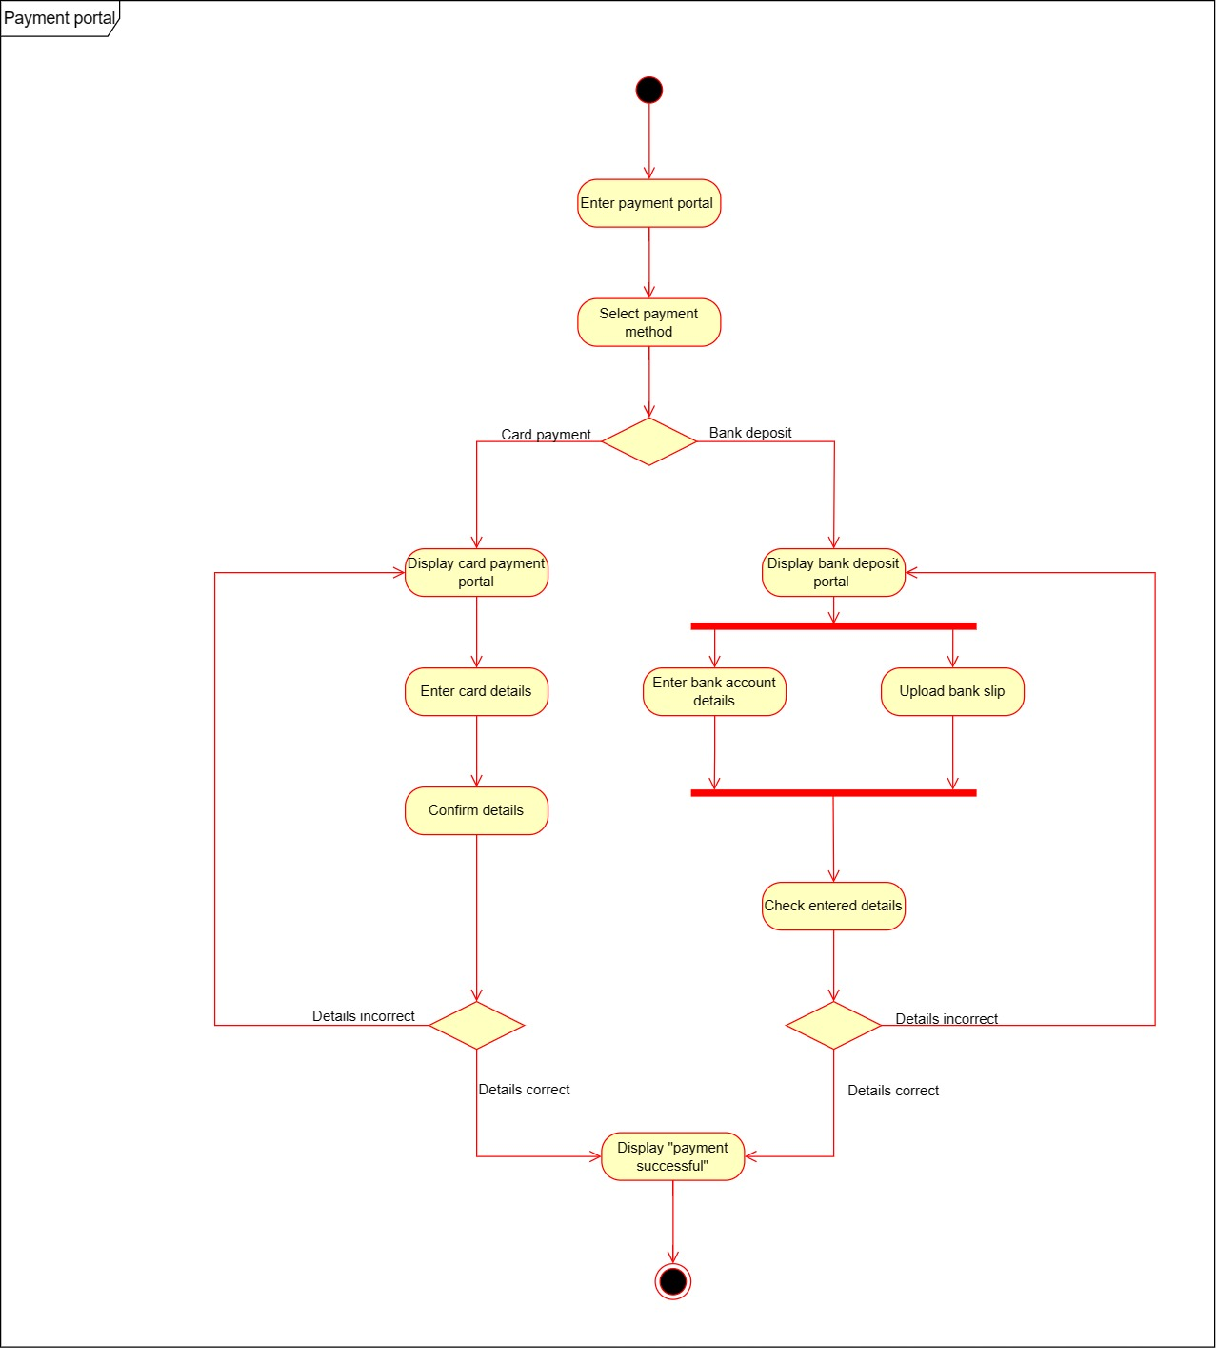

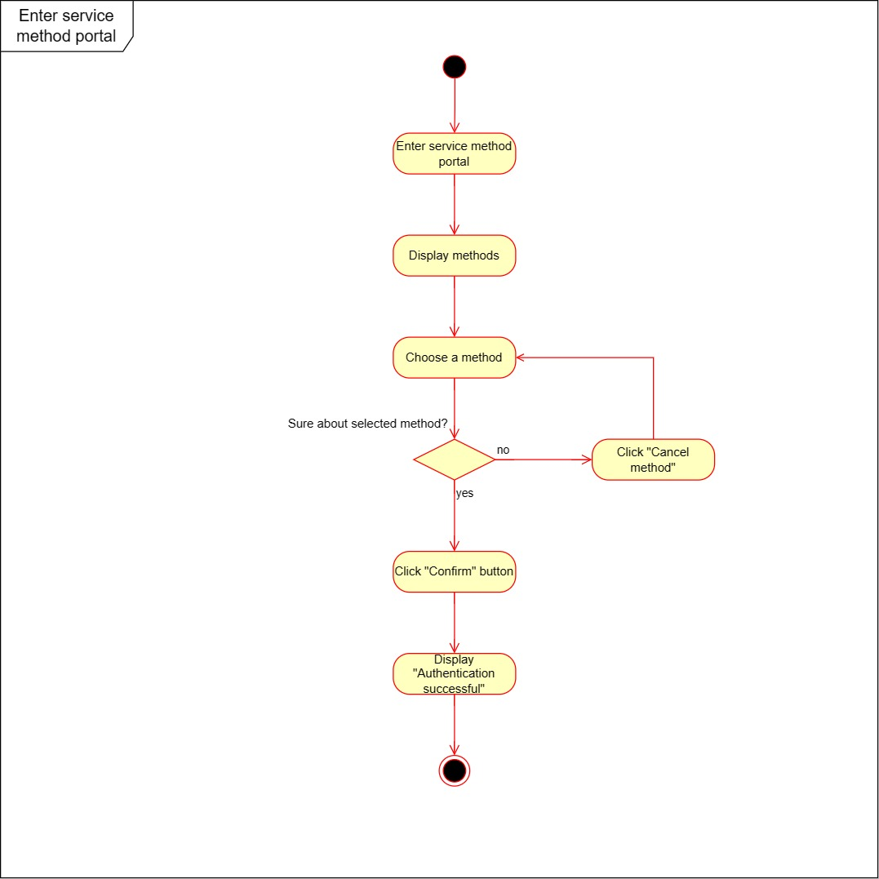

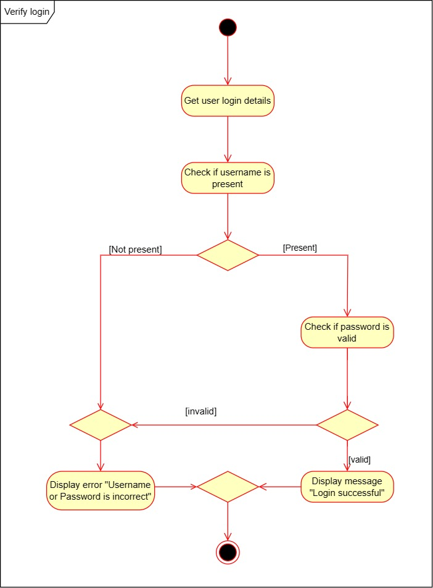

Part 02

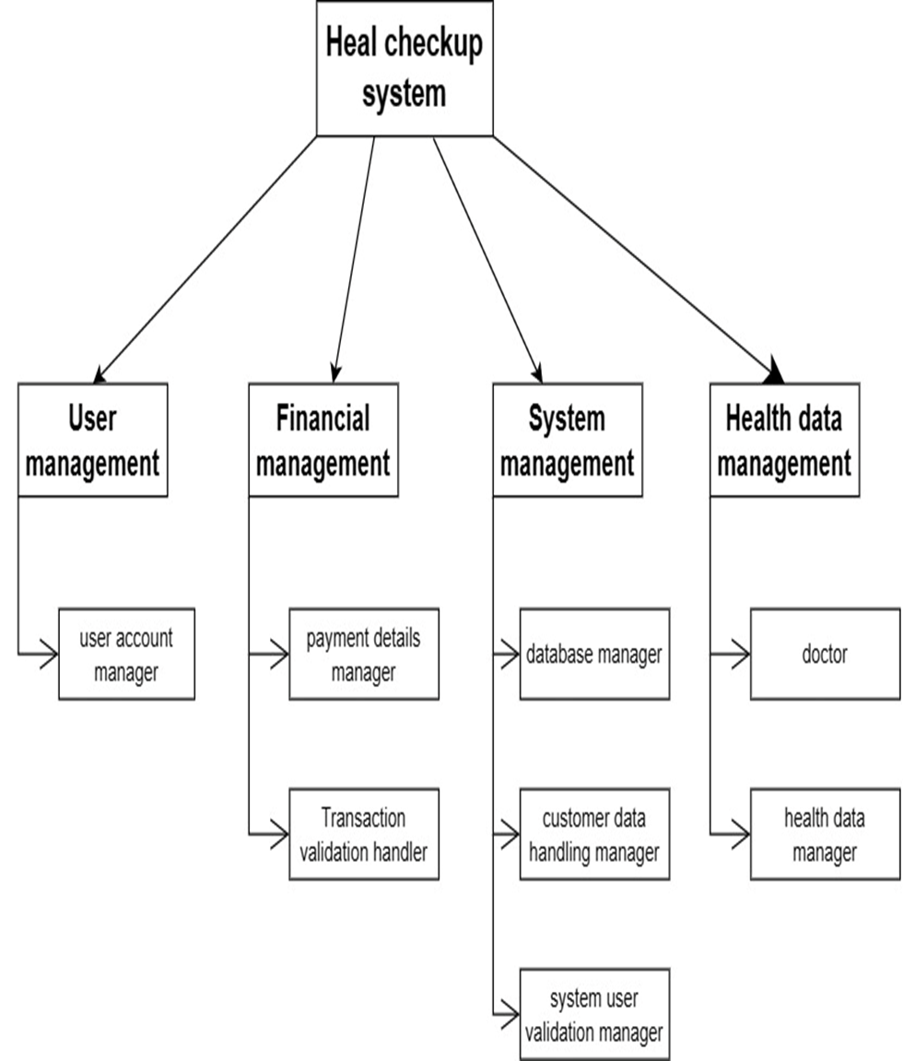

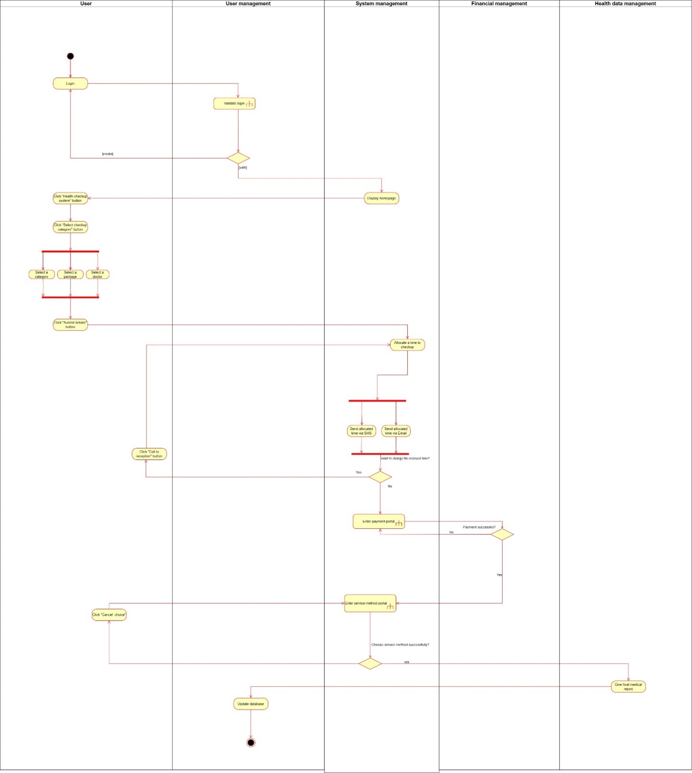

**Assignment 2 Certify Sheet**

|  |
| --- |
| I hereby certify,  The attached is my own work and no further changes will be made.  I have contributed in this assignment to the best of my ability.  And I understand,  I may be subject to student discipline processes in the event of an act of academic misconduct by me including an act of plagiarism or cheating. |

|  |  |  |  |
| --- | --- | --- | --- |
|  | **Student Registration** |  |  |
| **Student Name** | **Number** | **Date** | **Signature** |
| PERERA K.C.D | IT22566034 | 29.05.2023 |  |

**Student Details:**

Part 01

**Use case scenario – Diet plan**

|  |  |  |
| --- | --- | --- |
| Number | 003 | |
| Name | Diet plan. | |
| Summary | Creating meal plans for patients. | |
| Priority | 03 | |
| Preconditions | Patient has logged into the system and has completed a health check-up. | |
| Postconditions | The patient has a diet plan. | |
| Primary Actor(s) | Patient. | |
| Trigger | The patient selects the "Create Diet Plan" option from the main menu. | |
| Main Scenario | Step | Action |
|  | 1 | Patient logs in to the diet planning system. |
| 2 | Patient requests a diet plan. |
| 3 | Schedules a health check-up appointment. |
| 4 | Doctor reviews the patient's health check-up reports and determines whether the patient needs a diet plan. |
| 5 | The nutritionist reviews the reports and assesses the patient's dietary needs, preferences, and goals. |
| 6 | The nutritionist creates a personalized meal plan based on the review. |
| 7 | The fitness specialist reviews the reports and creates an exercise plan. |
| 8 | The system ultimately provides the patient with a personalized meal plan and exercise plan. |
| 9 |  |
| Extensions | Step | Branching Action |
|  | 6.a | The patient disagrees with the diet plan and the nutritionist prepares a new diet plan. |
| 7.a | The patient disagrees with the exercise plan and the fitness expert prepares a new exercise plan. |
| Open Issues | 1 |  |

Part 2

**Assignment 2 Certify Sheet**

|  |
| --- |
| I hereby certify,  The attached is my own work and no further changes will be made.  I have contributed in this assignment to the best of my ability.  And I understand,  I may be subject to student discipline processes in the event of an act of academic misconduct by me including an act of plagiarism or cheating. |

**Student Details:**

|  |  |  |  |
| --- | --- | --- | --- |
|  | **Student Registration** |  |  |
| **Student Name** | **Number** | **Date** | **Signature** |
| JAYALATH J.P.R.J | IT22591098 | 29.05.2023 |  |

Part 01

**Use case scenario – Manage user account**

|  |  |  |
| --- | --- | --- |
| **Number** | 4 | |
| **Name** | Manage user account | |
| **Summary** | Administered by System admin | |
| **Priority** | High | |
| **Preconditions** | The system admin needs to manage the client's data | |
| **Postconditions** | System admin control by the system | |
| **Primary Actor(s)** | System Admin | |
| **Trigger** | The system manager decides to generate reports | |
| **Main Scenario** | **Step** | **Action** |
|  | 1 | Log in to the system as an Admin |
| 2 | Validity check at system login |
| 3 | If invalid login Details “Display Invalid Login” |
| 4 | Otherwise Display dashboard |
| 5 | Click on manage user Account tab and select Manage User Account or Manage Admin User Account |
| 6 | Edit and view Account Details user |
| 7 | reset password user Account |
| 8 | Save and changes and update to the data base |
| **Extensions** | **Step** | **Branching Action** |
|  | 1.a | Admin user account & regular user account visited manage user account System Audit and Administration |
| 6.a | Check admin or user Account? |
| 6.b | If admin can select User to Edit and after display user details. But user direct display user details |
| 6.c | User can access modify data modify by user |
| 6.d | User can’t account access admin should give access to user or update Data by Admin and modify data. |
| 7.a | User click forget password |
|  | 7.b | User provides email or username |
|  | 7.c | If it’s invalid display the “invalid email or username entered” |
|  | 7.d | If Else send password verification OTP to the user |
|  | 7.e | Give access to the user reset password. |
|  | 7.f | After update new password and check the password relogging using new password. |
|  |  |  |
| **Open Issues** | 1 | Each section must be individually inspected and controlled |

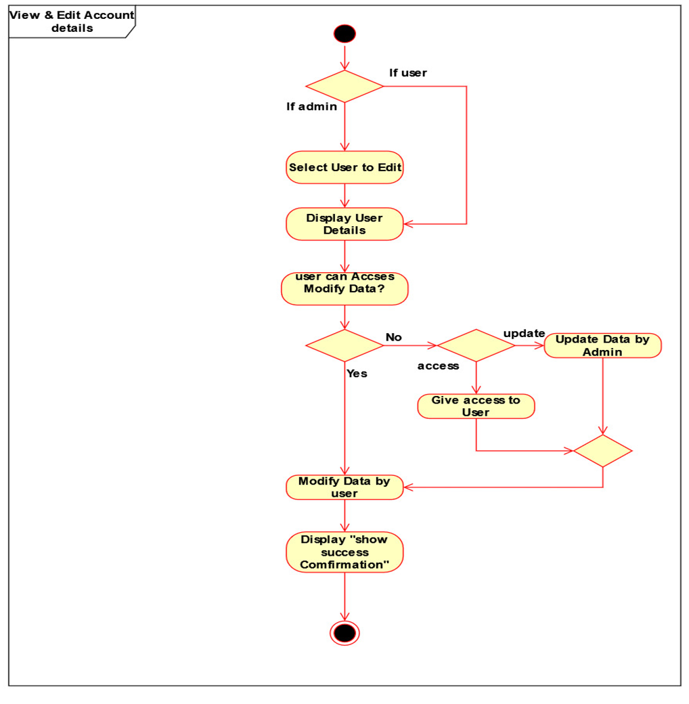

Part 02

01

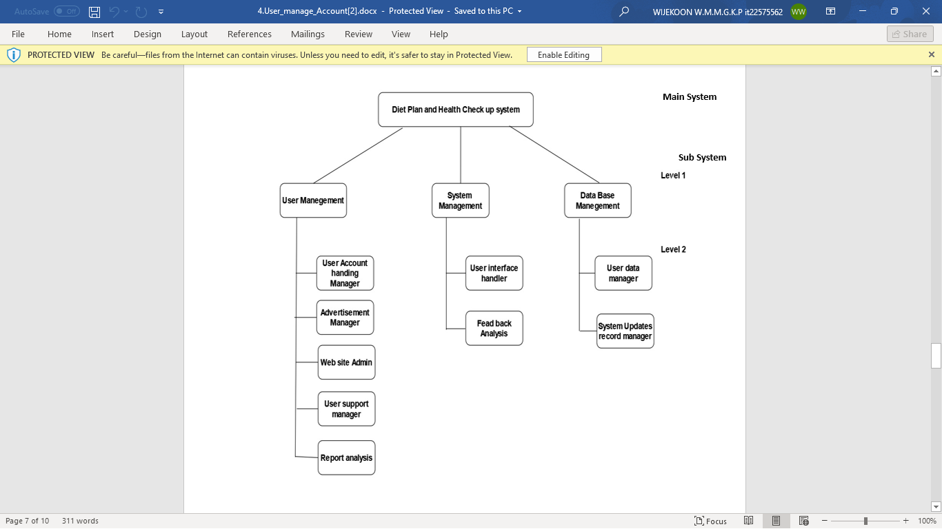

**2.** Manage User Account

View And edit Account Details

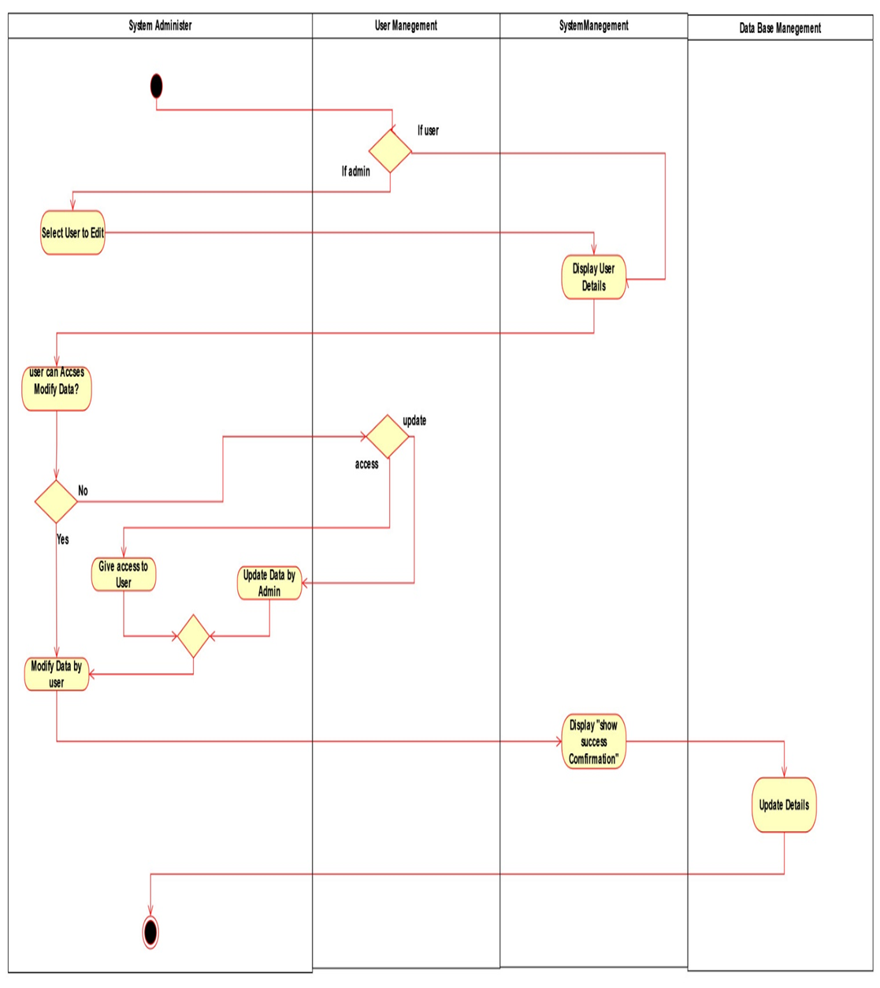

**Assignment 2 Certify Sheet**

|  |
| --- |
| I hereby certify,  The attached is my own work and no further changes will be made.  I have contributed in this assignment to the best of my ability.  And I understand,  I may be subject to student discipline processes in the event of an act of academic misconduct by me including an act of plagiarism or cheating. |

|  |  |  |  |
| --- | --- | --- | --- |
|  | **Student Registration** |  |  |
| **Student Name** | **Number** | **Date** | **Signature** |
| WIJEKOON W.M.M.G.K.P | IT22575562 | 29.05.2023 |  |

**Student Details:**

|  |  |  |
| --- | --- | --- |
| **Number** |  | 005 |
| **Name** |  | Generate Report |
| **Summery** |  | Report handler gets detailed report |
| **Priority** |  | 05 |
| **Pre-Condition(s)** |  | Report handler should login to his dashboard |
| **Post-Condition(s)** |  | System gives fully detailed report |
| **Primary Actor(s)** |  | Report handler |
| **Trigger** |  | when report handler wants to get report |
| **Main Scenario** | **Step** | **Action** |
|  | 1 | Reports handler(user) goes to the page |
|  | 2 | click on ‘log-in’ button |
|  | 3 | enters the valid his log-in credentials |
|  | 4 | System Validate the report handler |
|  | 5 | user move on to the admin panel |
|  | 6 | Click on ‘R**eport”’** tab |
|  | 7 | System shows the Reports categories |
|  | 8 | user select which data he wants |
|  | 9 | System ask to confirmation the selected data |
|  | 10 | System Ask how to save the report/which format |
|  | 11 | user gives the file format |
|  | 12 | System generates the report. |
|  | 13 | System asks from user to display or save the report |
|  | 14 | User specifies a location to save the report or click on display option |
|  | 15 | System saves the report to the specified location or display the report |
| **Extensions** | **Step** | **Branching Action** |
|  | 3.a | If the user credentials are invalid  3.a.1 – system generate an error message  3.a.2 – system indicates a new prompt box to re-enter valid log-in details |
|  | 4.a | If validation is failed.  4.a.1 – after entering valid credentials and validation is pass user can go forward |
|  | 12.a | If system failed to generate the report |

**Part 1**

**1. Use case scenario- Generate Report**

**2.** Generate Report

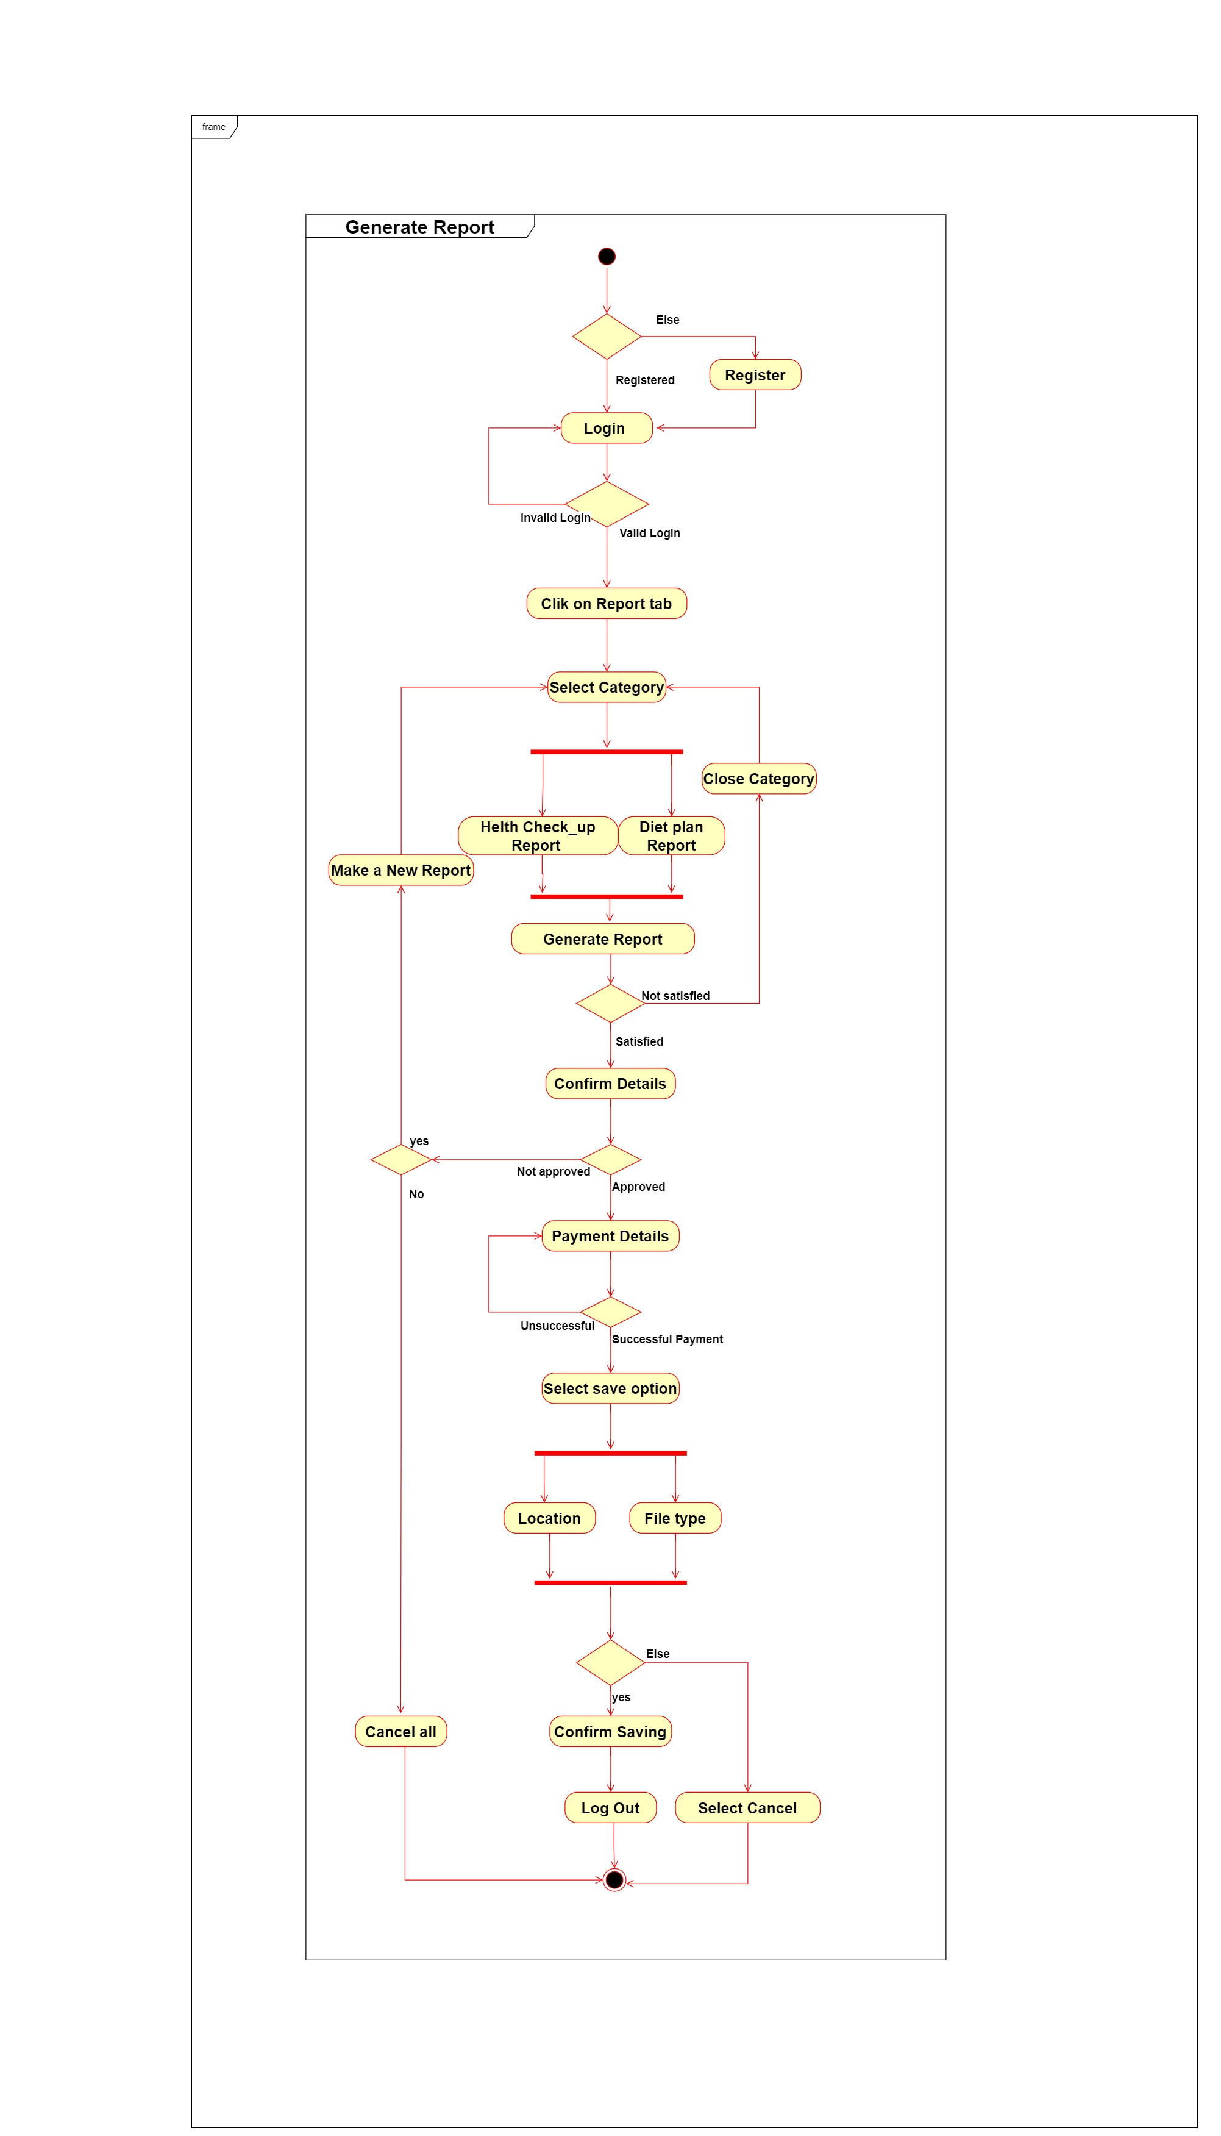

Select data

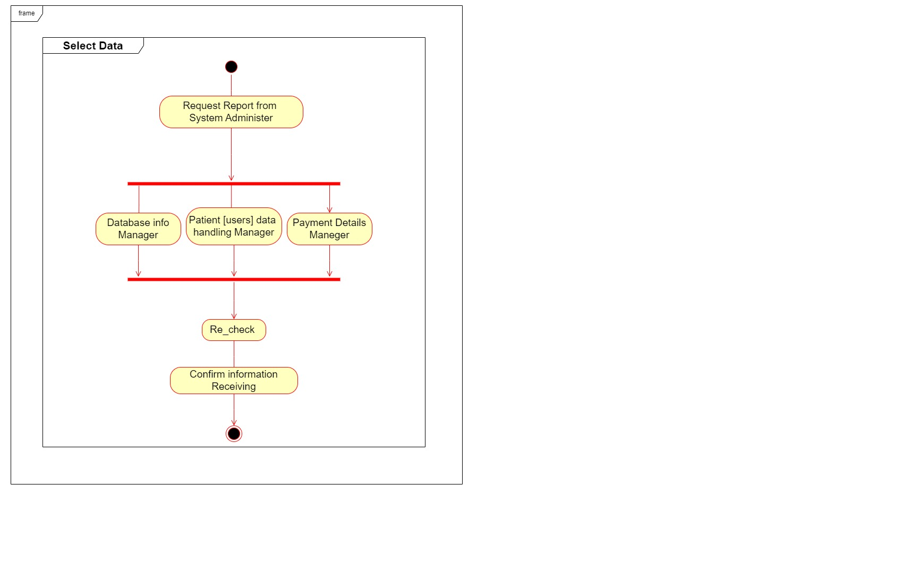

**Part 2**

**1.**

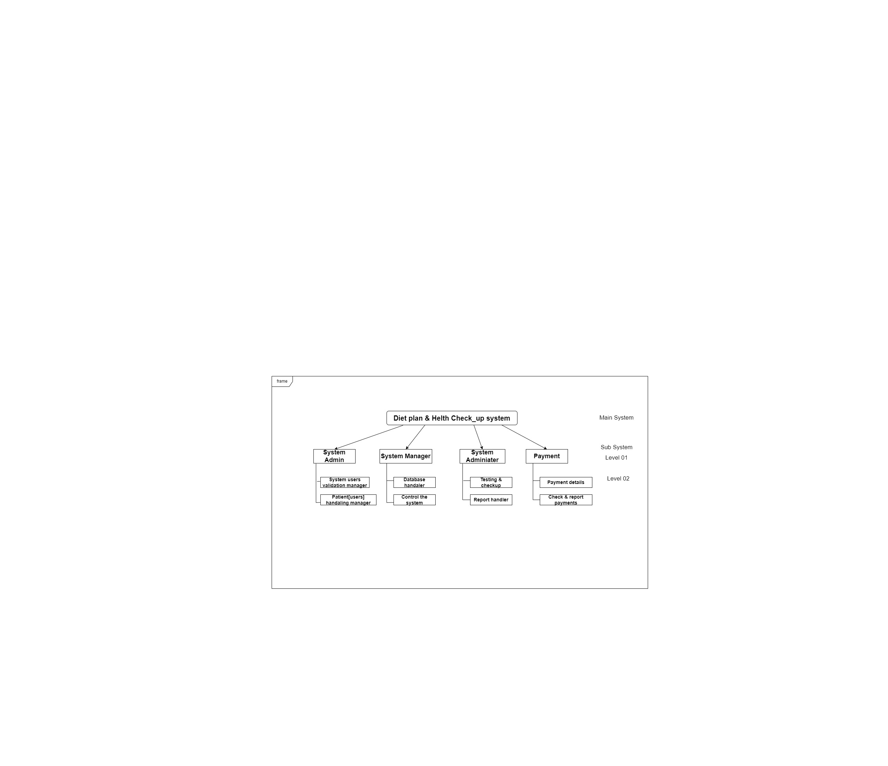

**2.**

